**A PROJECT REPORT**

**ON**

**(DINE@myTime)**

*Submitted by*

**Avani Sanghvi [170410107099]**

**Sarvesh Purohit [170410107091]**

**Dhruv Bhavsar [170410107006]**

***In partial fulfilment***

***Of***

**BACHELOR OF ENGINEERING**

***in***

**COMPUTER ENGINEERING**



**SARDAR VALLABHBHAI PATEL INSTITUTE OF TECHNOLOGY,**

**VASAD**

**Gujarat Technological University, Ahmedabad**

**2020-2021**

**SARDAR VALLABHBHAI PATEL INSTITUTE OF TECHNOLOGY, VASAD**

**COMPUTER ENGINEEERING DEPARTMENT**



**CERTIFICATE**

**Date: 21-04-2021**

**This is to certify that the project entitled “DINE@myTime” has been carried out by Avani Sanghvi [170410107099], Sarvesh Purohit [170410107091], Dhruv Bhavsar [170410107006]. under my guidance in partial fulfilment of the project in Bachelor of Engineering in Computer Engineering 8th semester of Gujarat Technological University, during the academic year 2020-2021.**

**Internal Guide: Head of Department:**

**Prof. Nitin Patel Prof. Dr. Neha Soni**

**Assistant Professor C.E. Department**

**S.V.I.T. Vasad S.V.I.T. Vasad**

* As our app be developed in android so it will be only used by android user and will not be applicable for iOS user.

proposed system.* Minimum 2 GB RAM / 4 GB SPACE2.5. System Limitation (In which condition/ environment system will not work): -

the organization.Technical feasibility also involves the evolution of the hardware, software, and other the technical requirements of the

procedures, existing software technology and available technical hardware. This assessment focuses on the technical resources available to

accessible through any android mobile.The technical feasibility is worked for the project is done with the present equipment, manual

at any certain time due to viruses or operating system failures. Therefore, it is required to take the database backup.* Our application will

request, when using 3G or 4G Internet connection. * Our app will be supportable in every android mobiles.* The database may get crashed

verification need to be done whenever required at any stage of activity. * Our app will not take longer than 10 seconds to respond to a

presented in a simple way.* Our app will be available for users but in some maintenance days, it will not be available. Data validation and

be stored in encrypted form.* The navigation in the app will be user-friendly i.e.table layout, menus and each and every detail will be

* Restaurant has the authority for managing the orders.* Users can view booked order detail and take a report of that. * Passwords should

Also provide help regarding our app working issues if needed.* Admin has highest authority to manage customers and restaurants.

their convenience .View menu and place order in advance* Management System: Admin will manage customers and restaurant account.

Profile: View Profile, Edit Profile , View Order History* Table Booking and Menu Ordering: View Table Layout and book table according to

restaurants.5) What are the solutions be provided by our project to overcome the problems faced by people? * Registration/Login and

people are not able to follow “social distancing” due to rush at restaurants. So, it is also a big problem nowadays for both customers and

wait for the food to be served at their table so this results into their time waste. * As far as the current situation of COVID-19 is concerned,

restaurant food but there is a big queue and customers have to wait for table to be vacant and even after acquiring the table, they have to

not being followed so customers avoid going much in restaurants and so the restaurants are also at loss. * As there is increasing demand for

us about the issues of waiting queue for table reservation and managing the queue respectively. * Due to long waiting, social distancing is

by their customers and their staff as well and we3) What are the data or information we collected?* Both the customers and restaurants told

and functions.* We talked with few Restaurant Managers of different restaurants and we opted the project by knowing the problems faced

friends and relatives, we get to know the real time problem faced by people regarding the restaurant long waiting especially on occasions

restaurant and so social distancing is followed.1) How do we find our definition on project?* By discussing amongst ourselves and with

their likings and privacy.* Our product is very beneficial in this COVID-19 pandemic as there won’t be waiting and rush to acquire a table in

top picks through the analysis of customer’s liking history.We will also provide the view of tables so people can book tables according to

Also, an alert message facility is provided if vacant table available before booked timings. * We will use ML concepts for recommendation of

problems through our system or application by booking a table in any restaurant from anywhere and can also order their meal in advance.

(especially during special occasions) to acquire a table in restaurant and having the food at our table. * So, here our aim is to resolve these

food is increasing.The youngsters and elders love to go to restaurants and enjoy the food. But as we know that there is a long waiting

restaurant.We will also display the top most pick items in the restaurant being selected by the user. * As nowadays demand for restaurant

anywhere at any time and a* Our goal is to save our customers’ time and also to maintain social distancing by not having rush of people at

* Our app will give the users the easiness of booking table according to their convenience, viewing menu, order their food in advance from

**Content Checked For Plagiarism**

**Plagiarised**

**Unique**

**10%**

**90%**

**Characters**

5569

**Words**

995

**Date**

2020-11-18

**PLAGIARISM SCAN REPORT**

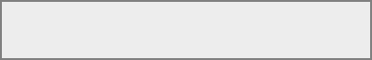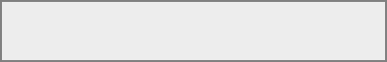

https://www.developer.com/ws/android/android-studio-tutorial-an-introduction.html

in the section.

whichassuming that android studio is installed in your system, we will explore how we can create a simple application using android studio

android studio contains tools such as the android virtual device manager and the android device monitor. it also contains gradle,

**Title**: Android Studio Tutorial: An Introduction - Developer.com

**Similarity 3%**

https://download.zone/bluestacks-old-versions-free-download/

Android Emulator build on ...

BlueStacks founded in 2011 in the USA, it is a technology company and widely popular for their BlueStacks App Player which is an

**Title**: BlueStacks old versions safe and free download for windows ...

**Similarity 3%**

https://www.simplilearn.com/feasibility-study-article

proposed project.

resourcesconducting a feasibility study is always beneficial to the project as it gives you and other stakeholders a clear picture of the

this assessment focuses on the technical resources available to the organization. it helps organizations determine whether the technical

**Title**: Understanding Types of Feasibility Study, and Its Importance

**Similarity 3%**

https://www.coursehero.com/file/p54ipgc/Therefore-it-is-required-to-take-the-database-backup-so-that-the-database-is/

thing is bad english writing .i...

required to takeduring assignment did so much of research about questions i think it is another strong point. as weak points i think main

ratings 100% (4) 4 out of 4 people found this document helpful. this preview shows page 117 - 124 out of 130 pages. therefore, it is

**Title**: Therefore it is required to take the database backup... | Course Hero

**Similarity 3%**

https://www.scribd.com/document/364052452/Srs

of activity.

temporary password or a password reset link will be sent. 2.2.2. reliability data validation and verification needs to be done at every stage

passwords should be stored in encrypted form. password will not be mailed to the user in case user forgets. password, instead either

**Title**: Software Requirements Specification | Web Server | Use Case

**Similarity 4%**

**Matched Source**

and the Android Device Monitor.

* Proper internet speed is required for most of the app features.Android Studio contains tools such as the Android Virtual Device Manager

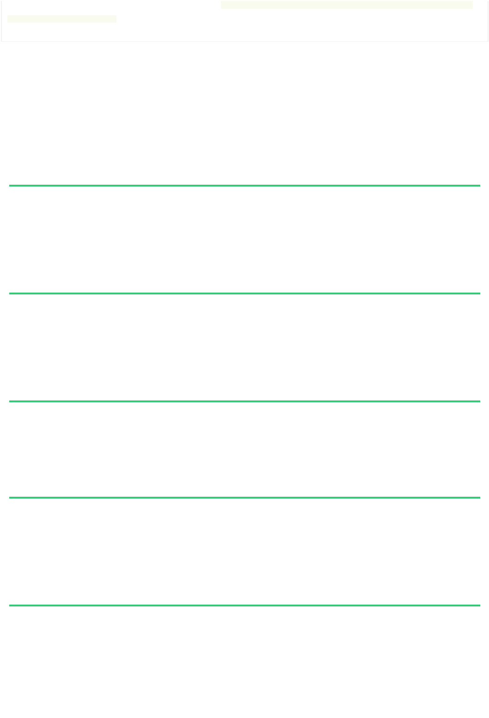

**Abstract: -**

* Our app will give the users the easiness of booking table according to their convenience, viewing menu, order their food in advance from anywhere at any time and a Take Away facility too.
* Our goal is to save our customers’ time and also to maintain social distancing by not having rush of people at restaurant. We will also display the top most pick items in the restaurant being selected by the user.

INDEX

|  |  |  |  |  |  |  |
| --- | --- | --- | --- | --- | --- | --- |
|  |  | |  |  | | Page No |
|  | Title Page | | | | | 1 |
|  | Certificate from College | | | | | 2 |
|  | Completion Certificates (from PMMS portal) | | | | | 3 |
|  | Plagiarism Report Certificate | | | | | 4 |
|  | Acknowledgement | | | | | 5 |
|  | Abstract | | | | | 6 |
|  |  | | | | | |
| Sr. No. | | Content | | | |  |
|  | |  | | | |  |
| 1 | Chapter 1: Introduction | | | | | 10 |
|  | 1.1 | |  | Problem Summary and Introduction | | 10 |
|  | 1.2 | |  | Sodh Yatra | | 10 |
|  | 1.3 | |  | Work Plan (Timeline chart/ Gantt Chart) | | 12 |
|  |  | |  |  | |  |
| 2 | Chapter 2: Requirement Specification | | | | | 14 |
|  | 2.1 | |  | Functional Requirement | | 14 |
|  | 2.2 | |  | Non- Functional Requirement | | 14 |
|  | 2.3 | |  | System Requirements | | 15 |
|  |  | | 2.3.1 | Hardware Requirement | | 15 |
|  |  | | 2.3.2 | Software Requirement | | 16 |
|  | 2.4 | |  | Feasibility Study | | 16 |
|  |  | | 2.4.1 | Technical Feasibility | | 16 |
|  |  | | 2.4.2 | Operational Feasibility | | 17 |
|  |  | | 2.4.3 | Economic Feasibility | | 18 |
|  | 2.5 | |  | System Limitation (In which condition/ environment system will not work) | | 18 |
| 3 | Chapter 3: System Design: - | | | | | 19 |
|  | 3.1 | |  | System Architecture (Block diagram) | | 19 |
|  | 3.2 | |  | System Diagrams | | 20 |
|  |  | | 3.2.1 | Class Diagram | | 20 |
|  |  | | 3.2.2 | Use Case | | 21 |
|  |  | | 3.2.3 | Activity | | 24 |
|  |  | | 3.2.4 | Sequence Diagram | | 32 |
|  | 3.3 | |  | Database Design | | 36 |
|  |  | | 3.3.1 | E-R Diagram | | 36 |
|  |  | | 3.3.2 | Data Dictionary | | 37 |
| 4 | System Description | | | | | 41 |
|  | 4.1 | |  | Software Description | | 41 |
| 5 | System Implementation : - | | | | | 43 |
|  | 5.1 | |  | | Testing Planning | 43 |
|  | 5.2 | |  | | Test Levels | 44 |
|  | 5.3 | |  | | System Testing | 44 |
|  | 5.4 | |  | | Snapshots of the Application | 46 |
| 6 | Conclusion and future scope | | | | | 58 |
|  | Reference | | | | | 58 |
|  | Appendix A | | | | | 59 |
|  |  | | | | |  |

**List of Figures**

|  |  |  |
| --- | --- | --- |
| Sr. No. | Title | Page No |
|  | | |
| Figure 2.1 | For Loading and Caching Images | 15 |
| Figure 2.2 | For Heavy Animation | 16 |

**Chapter 1: Introduction: -**

* 1. **. Problem Summary and Introduction: -**
* As nowadays demand for restaurant food is increasing. The youngsters and elders love to go to restaurants and enjoy the food. But as we know that there is a long waiting (especially during special occasions) to acquire a table in restaurant and having the food at our table.
* So, here our aim is to resolve these problems through our system or application by booking a table in any restaurant from anywhere and can also order their meal in advance. (Main motto: TIME SAVING). Also, an alert message facility is provided if vacant table available before booked timings.
* We will use ML concepts for recommendation of top picks through the analysis of customer’s liking history. We will also provide the view of tables so people can book tables according to their likings and privacy.
* Our product is very beneficial in this COVID-19 pandemic as there won’t be waiting and rush to acquire a table in restaurant and so social distancing is followed.

**1.2. Sodh Yatra: -**

1) How do we find our definition on project?

* + By discussing amongst ourselves and with friends and relatives, we get to know the real time problem faced by people regarding the restaurant long waiting especially on occasions and functions.
  + Thus, we selected this definition.

2) To whom we contacted for project definition?

* + We talked with few Restaurant Managers of different restaurants and we opted the project by knowing the problems faced by their customers and their staff as well and we will try to resolve them all.

3) What are the data or information we collected?

* Both the customers and restaurants told us about the issues of waiting queue for table reservation and managing the queue respectively.
* Due to long waiting, social distancing is not being followed so customers avoid going much in restaurants and so the restaurants are also at loss.

4) What are the problems people(customers) are facing?

* As there is increasing demand for restaurant food but there is a big queue and customers have to wait for table to be vacant and even after acquiring the table, they have to wait for the food to be served at their table so this results into their time waste.
* As far as the current situation of COVID-19 is concerned, people are not able to follow “social distancing” due to rush at restaurants. So, it is also a big problem nowadays for both customers and restaurants.

5) What are the solutions be provided by our project to overcome the problems faced by people?

* **(Main motto: TIME SAVING)**

->Advance Restaurant and Table Booking.

->Prior Menu Ordering.

**1.3. Work Plan (Timeline chart/ Gantt Chart): -**

## 

## 

**Chapter 2: Requirement Specification: -**

**2.1. Functional Requirement: -**

* Registration/Login and Profile: View Profile, Edit Profile , View Order History
* Table Booking and Menu Ordering: View Table Layout and book table according to their convenience . View menu and place order in advance
* Take away: Order status
* Payment
* Management System: Admin will manage customers and restaurant account. Also provide help regarding our app working issues if needed.
* Reviews and Ratings

**2.2. Non-Functional Requirement**: -

1. **Security**

* Admin has highest authority to manage customers and restaurants.
* Restaurant has the authority for managing the orders.
* Users can view booked order detail and take a report of that.
* Passwords should be stored in encrypted form.

1. **Usability**

* The navigation in the app will be user-friendly i.e. table layout, menus and each and every detail will be presented in a simple way.

1. **Reliability**

* Our app will be available for users but in some maintenance days, it will not be available. Data validation and verification need to be done whenever required at any stage of activity.
* Validating user input.

1. **Performance**

* Our app will not take longer than 10 seconds to respond to a request, when using 3G or 4G Internet connection.

1. **Supportability**

* Our app will be supportable in every android mobiles.

1. **Safety Requirement**

* The database may get crashed at any certain time due to viruses or operating system failures. Therefore, it is required to take the database backup.

1. **Interface**

* Our application will accessible through any android mobile.

**2.3. System Requirements: -**

**2.3.1. Hardware Requirement: -**

* **Smart phone/tablet**

Secondary Storage: 4 GB (Minimum)

RAM: 2 GB(Minimum)

* **Computer/laptop**

Secondary Storage: 100 GB

RAM: 2 GB(Minimum)

**2.3.2. Software Requirement: -**

* Android Studio
* MySQL
* PHP
* Sublime Text
* XAMPP Server

**2.4. Feasibility Study: -**

* A feasibility study is an analysis that takes all of the projects relevant factors into account including economic, technical, legal, scheduling considerations – to ascertain the likelihood of completing the project successfully.

**2.4.1. Technical Feasibility: -**

The technical feasibility is worked for the project is done with the present equipment, manual procedures, existing   software technology and available technical hardware. This assessment focuses on the technical resources available to the organization. Technical feasibility also involves the evolution of the hardware, software, and other the technical requirements of the proposed system.

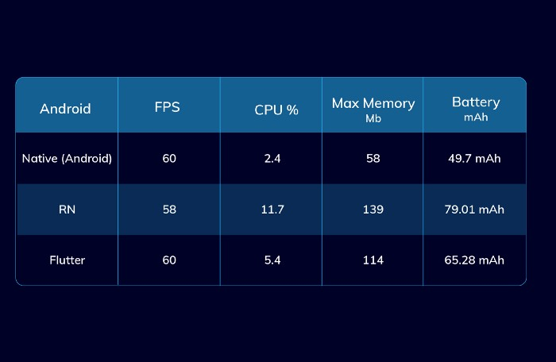

2.1 For Loading and Caching Images

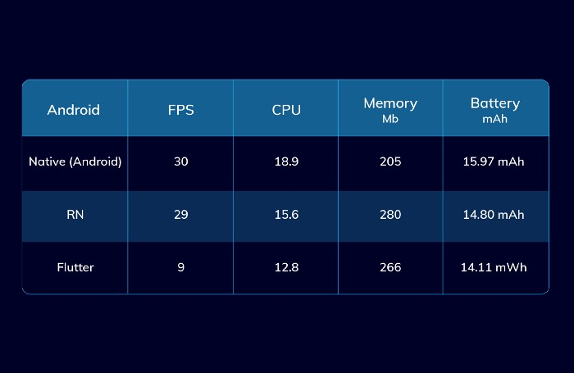

2.2 For Heavy Animation

**2.4.2. Operational Feasibility: -**

* The operational feasibility determines how the system will fit in the current operation. This system user friendly from a graphical user interface point of view and also proposed functionality is feasible from the development point of view .user have internet required the user can manage easily as well as simple. We put the all requirement to the user.

**Example**

* + Android mobile system
  + Minimum 2 GB RAM / 4 GB SPACE

**2.4.3. Economic Feasibility: -**

* This assessment typically involves a cost/benefits analysis of the project, helping the organization determine the viability, cost, and benefits associated with a project before financial resources are allocated. The proposed system economically feasible as it removes manual work, reduces the manual mistake, decreases the number of people working. Economic feasibility is the system where the users have economic to this system the agency has to provide the required software.

**2.5. System Limitation (In which condition/ environment system will not work): -**

* As our app be developed in android so it will be only used by android user and will not be applicable for iOS user.
* Proper internet speed is required for most of the app features.

**Chapter 3 : System Design: -**

**3.1. System Architecture (Block diagram): -**

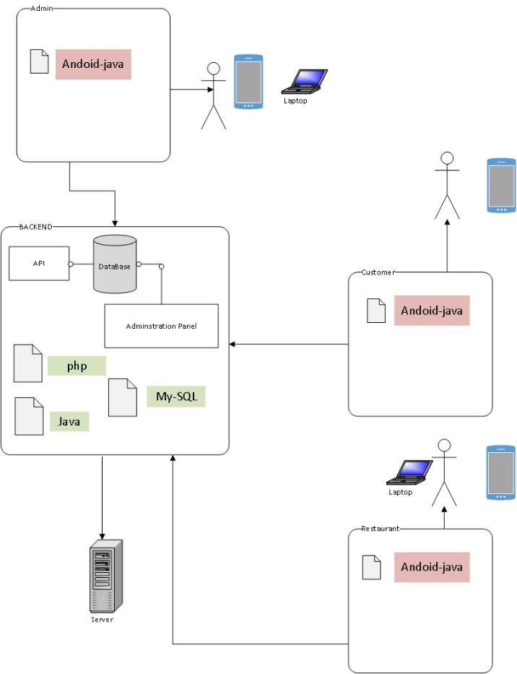

**3.2. System Diagrams: -**

**3.2.1. Class Diagram: -**

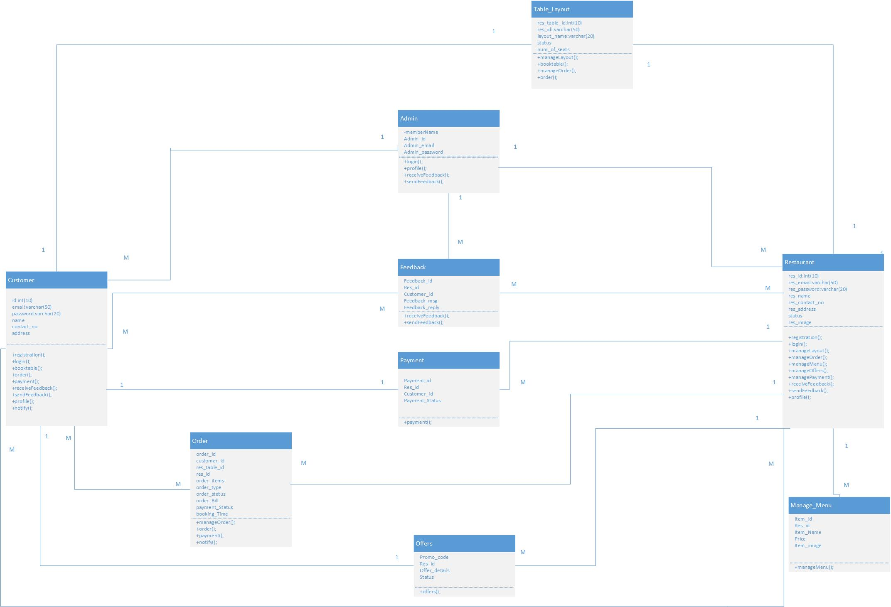

**3.2.2. Use Case: -**

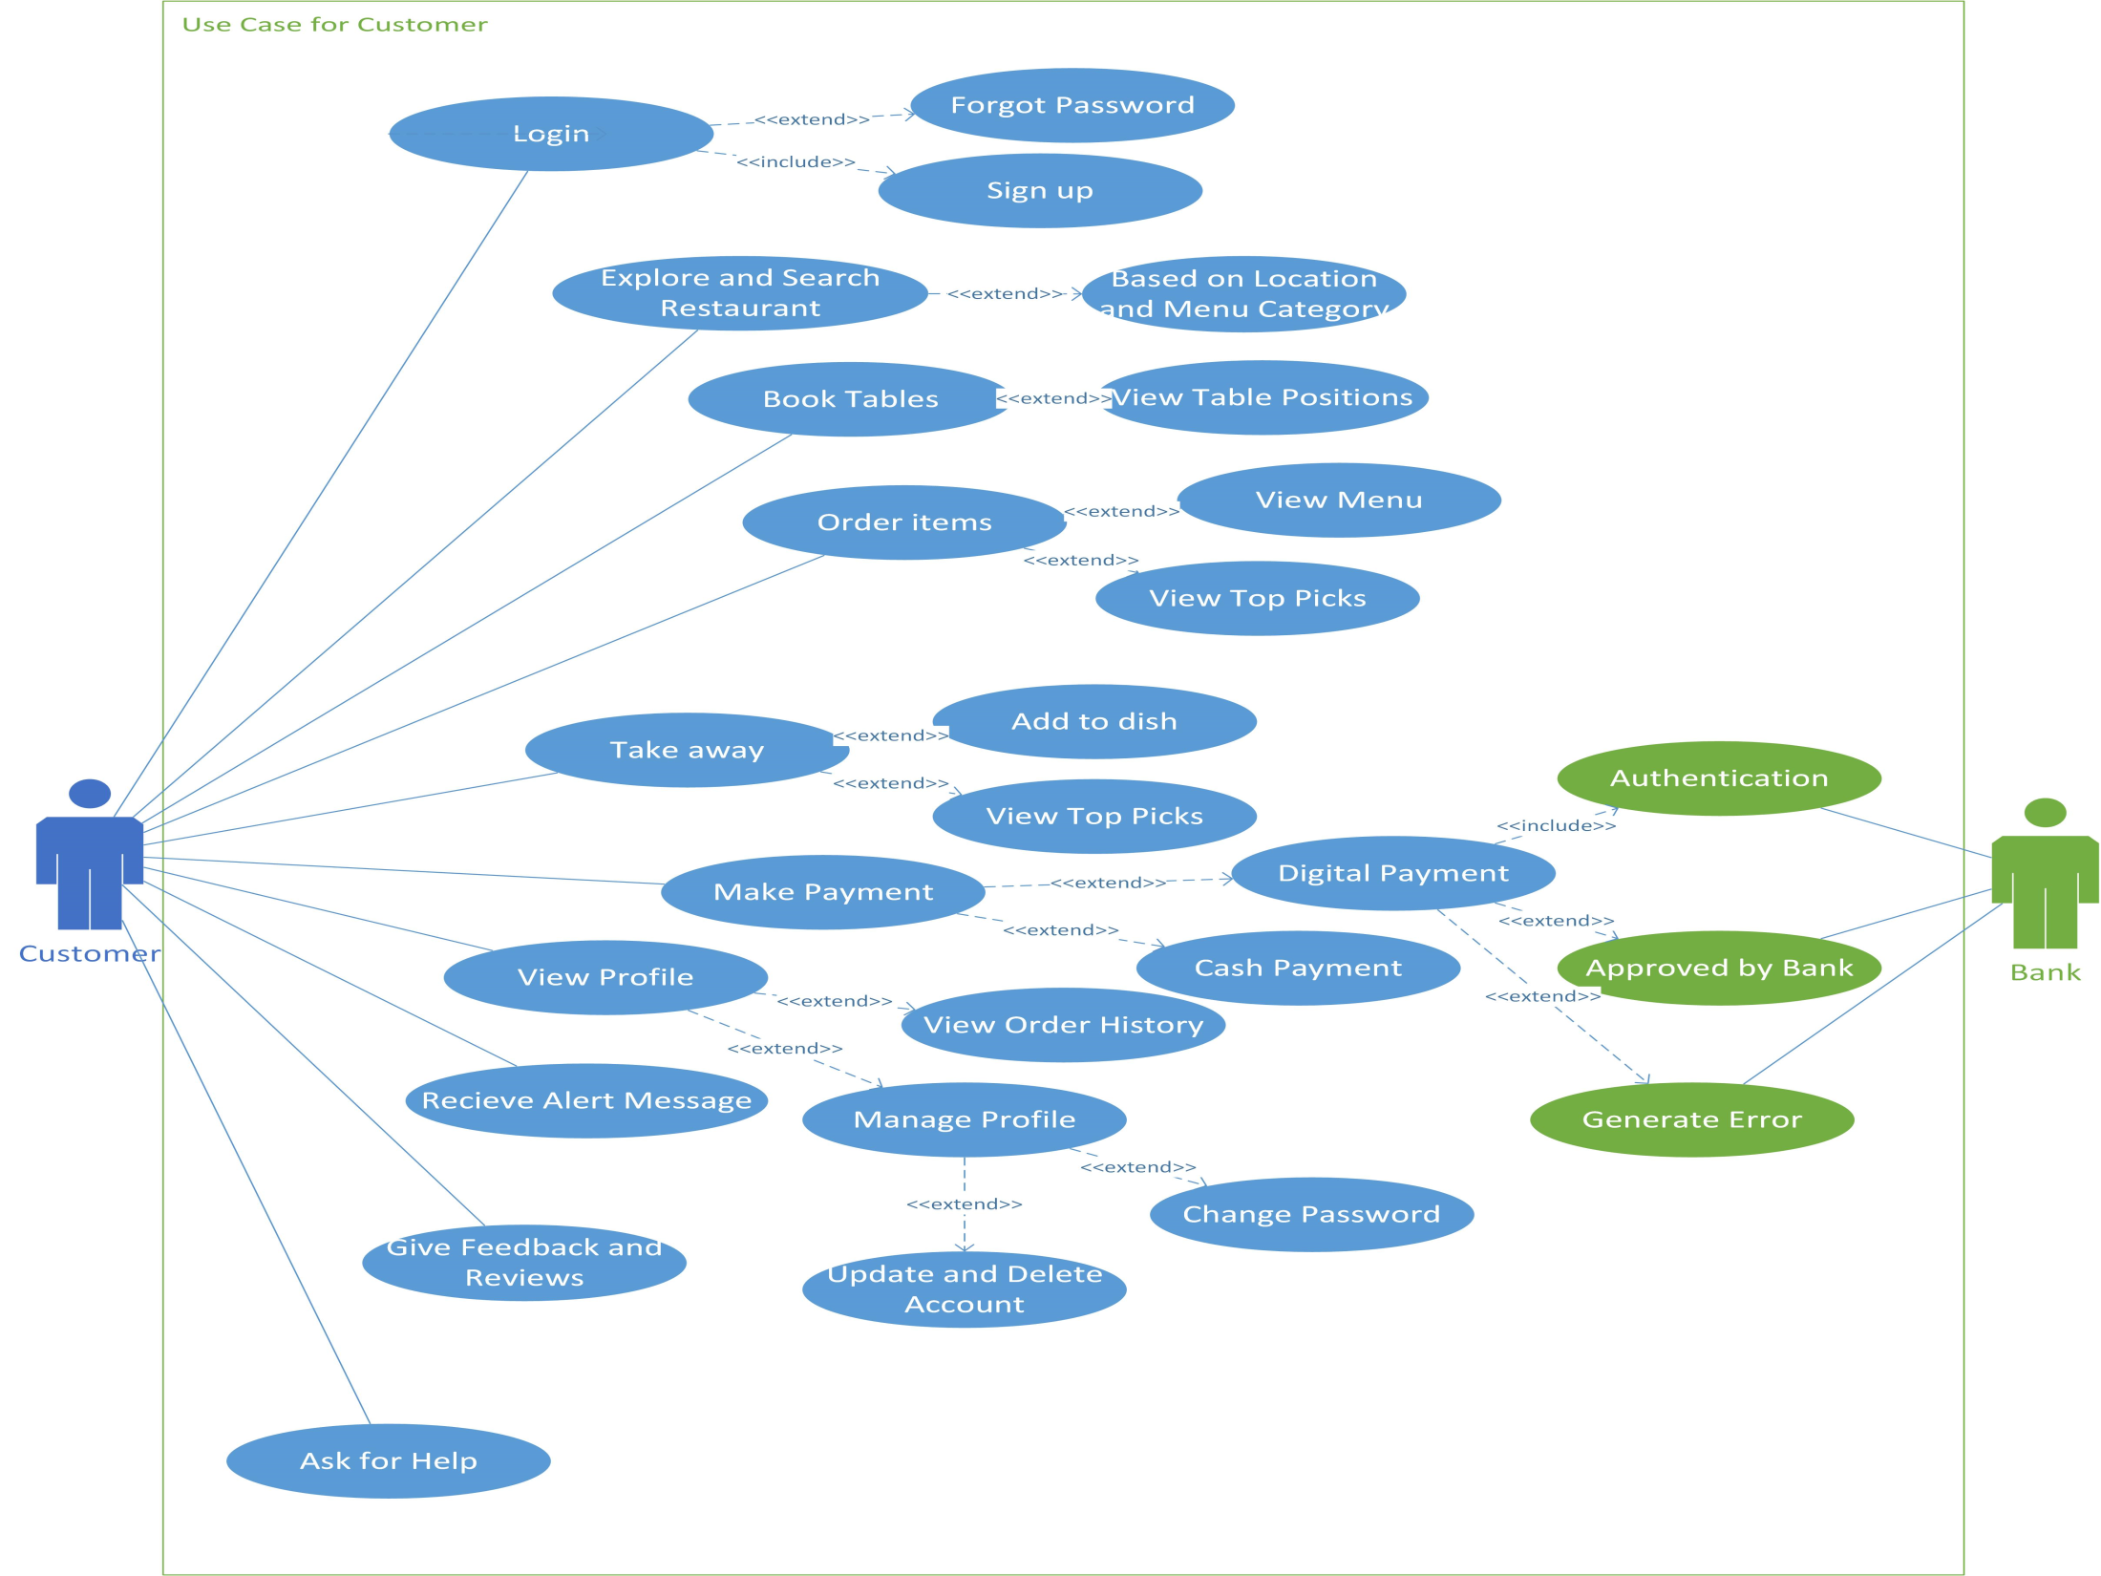



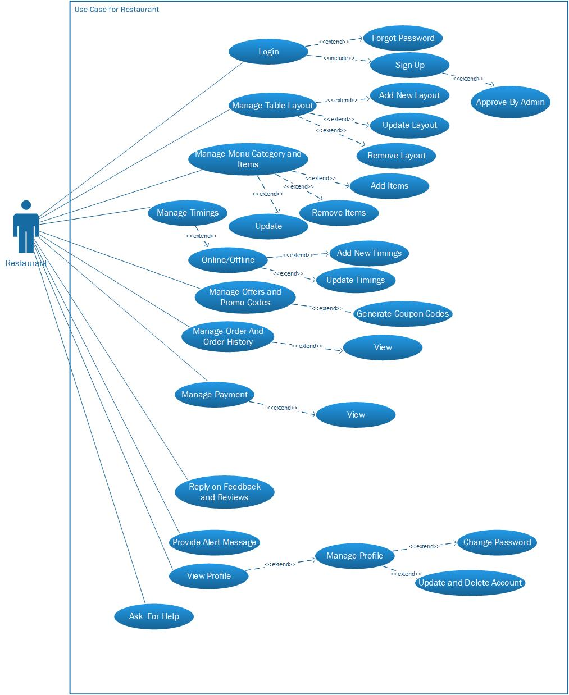

**3.2.3. Activity: -**

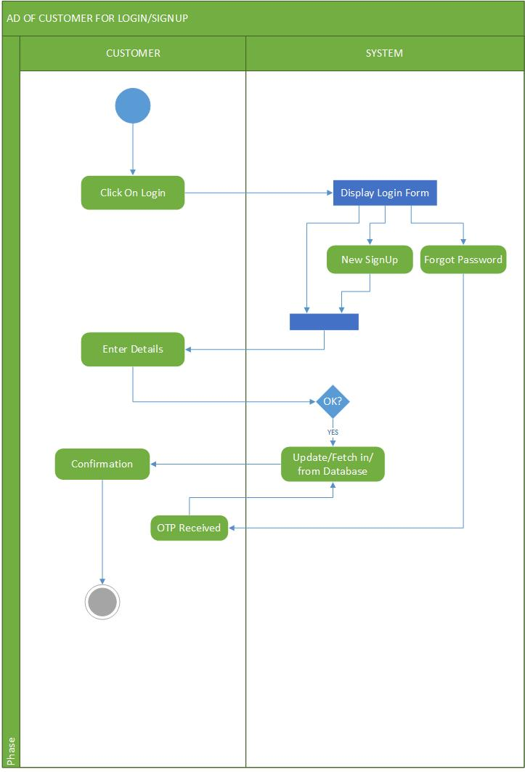

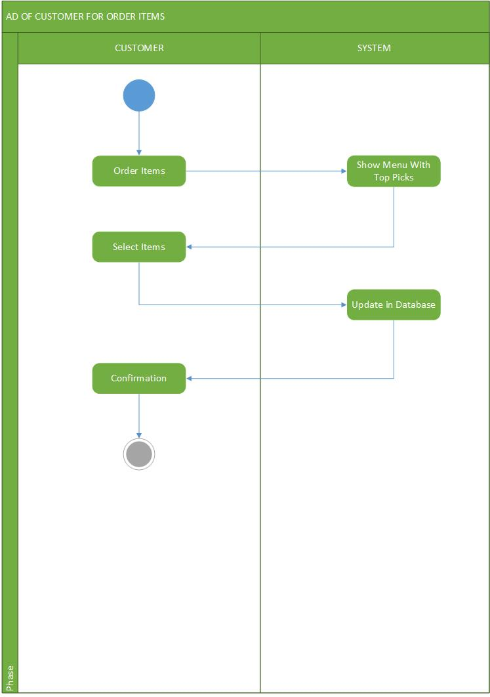

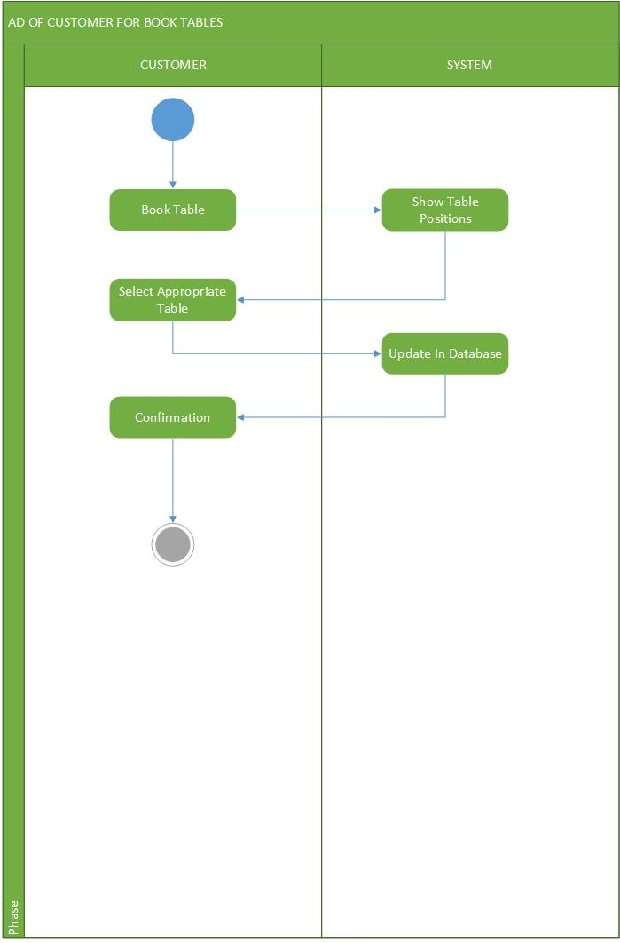

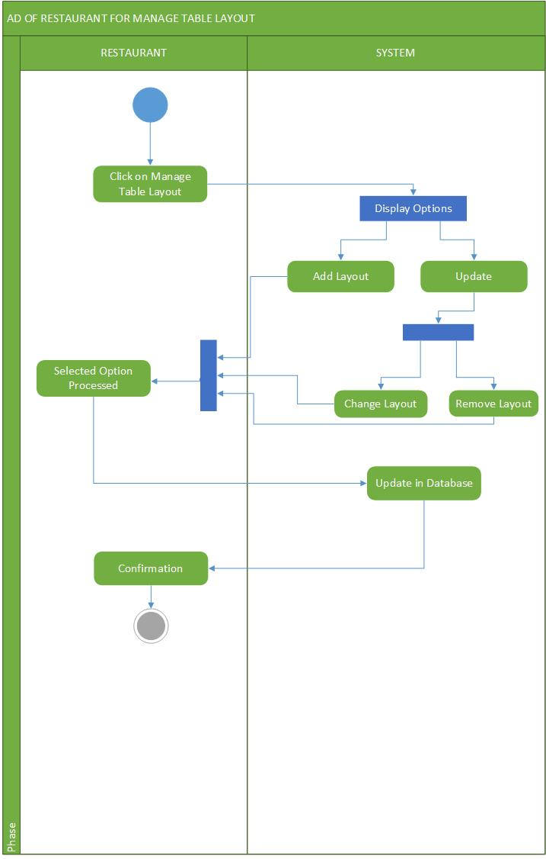

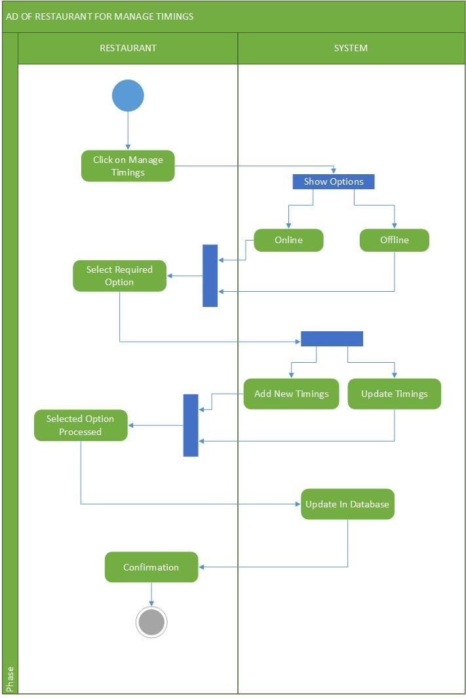

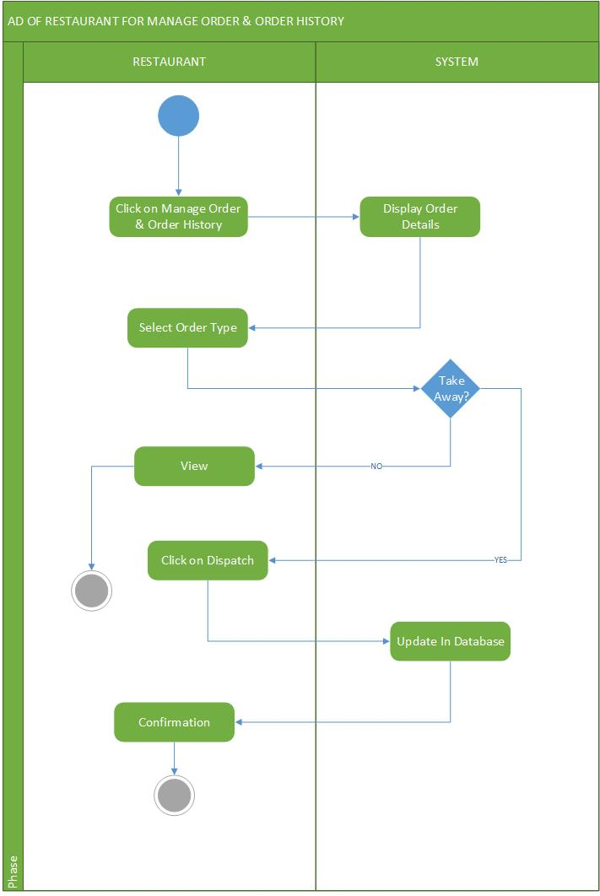

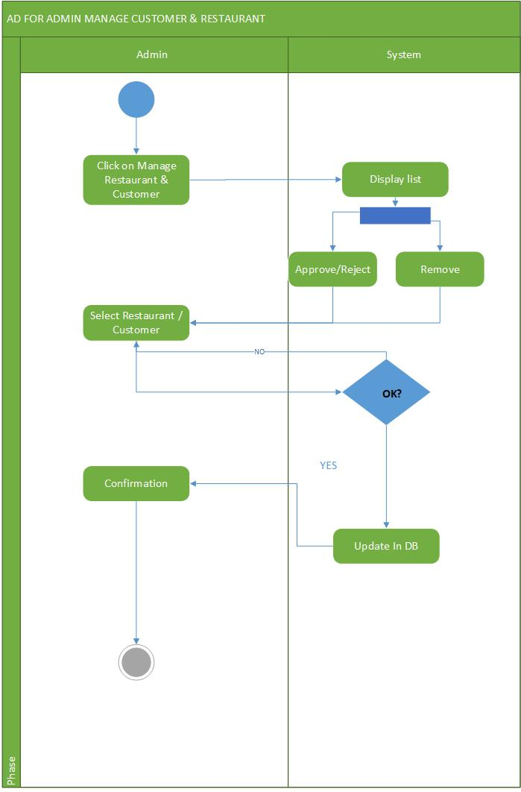

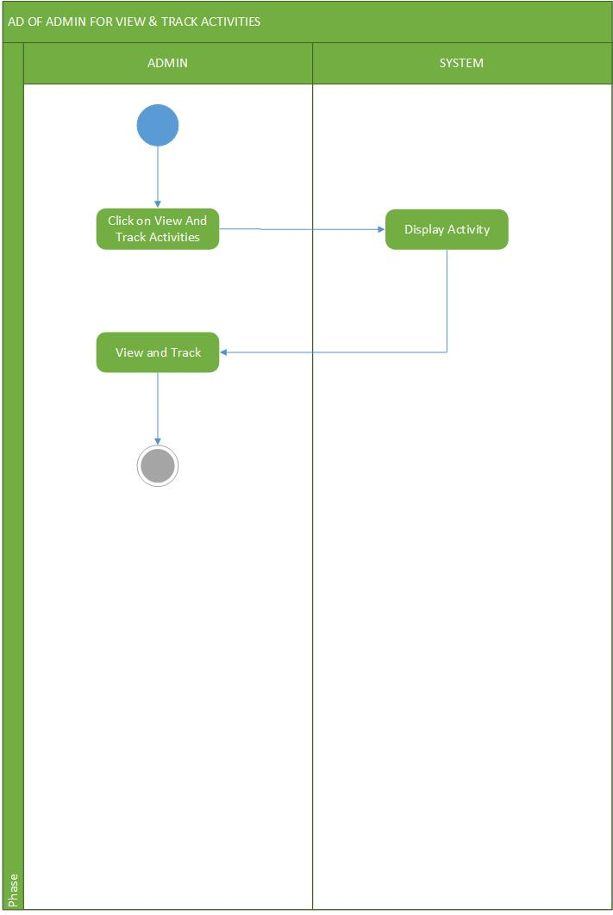

**3.2.4. Sequence Diagram: -**

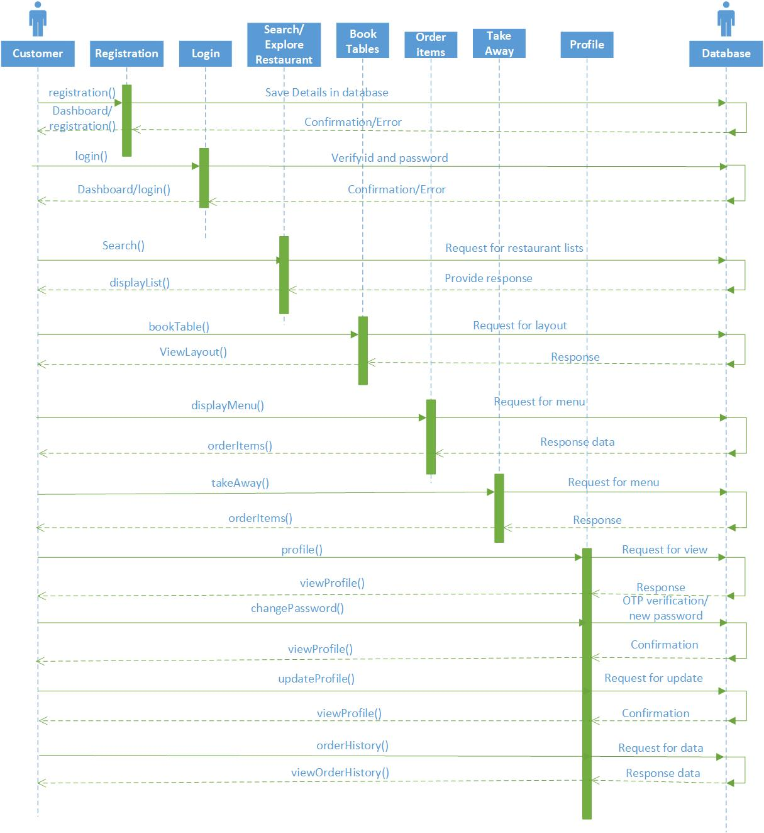

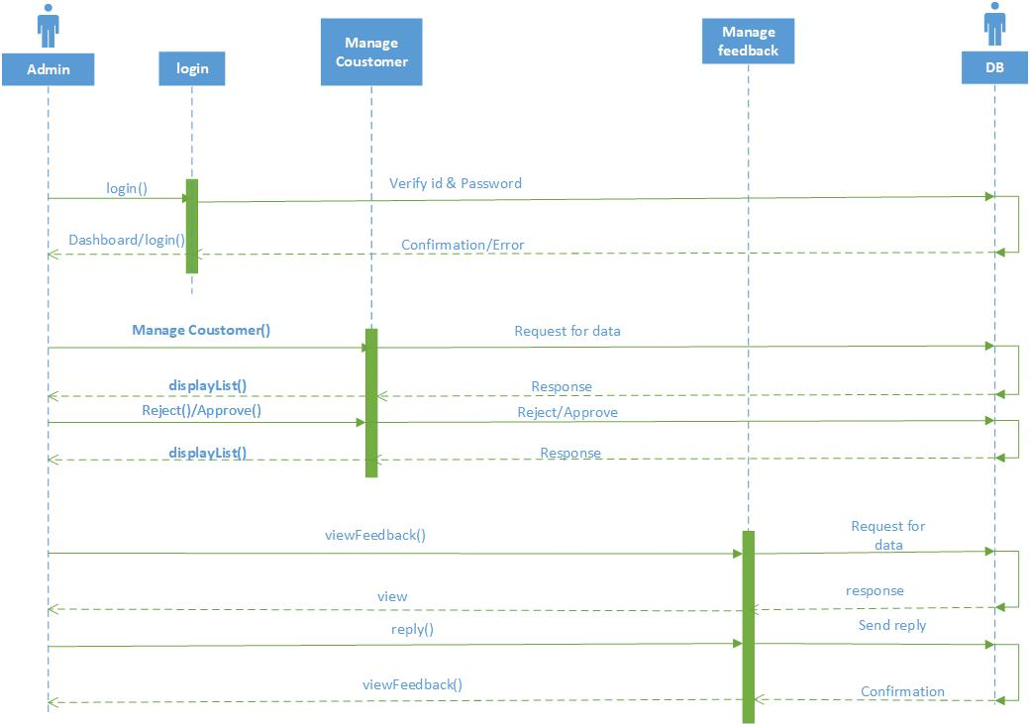

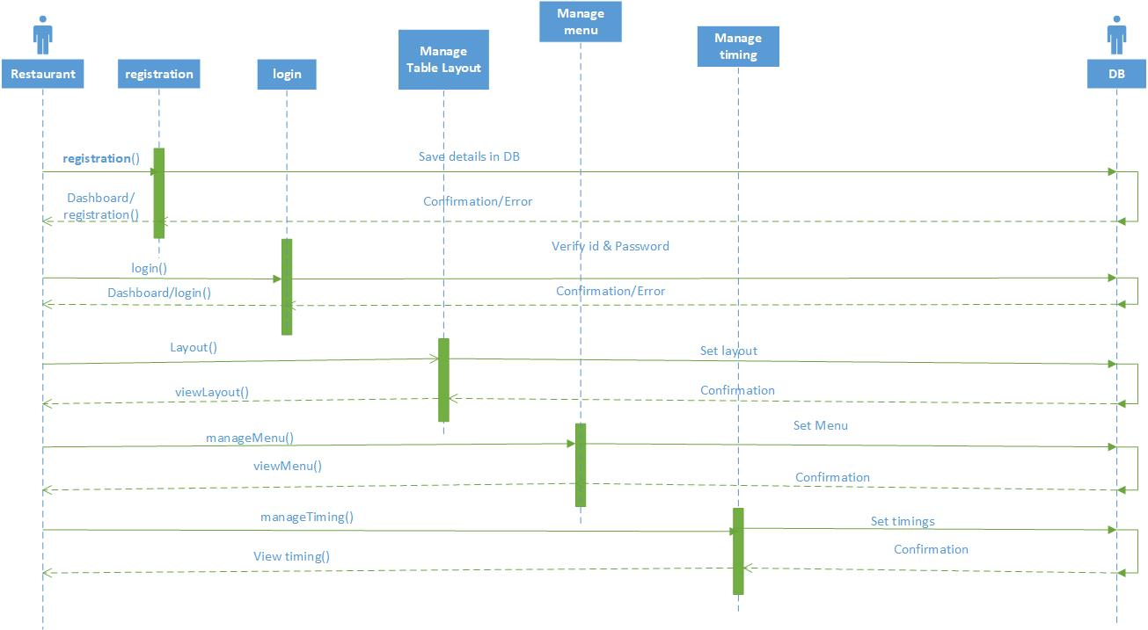

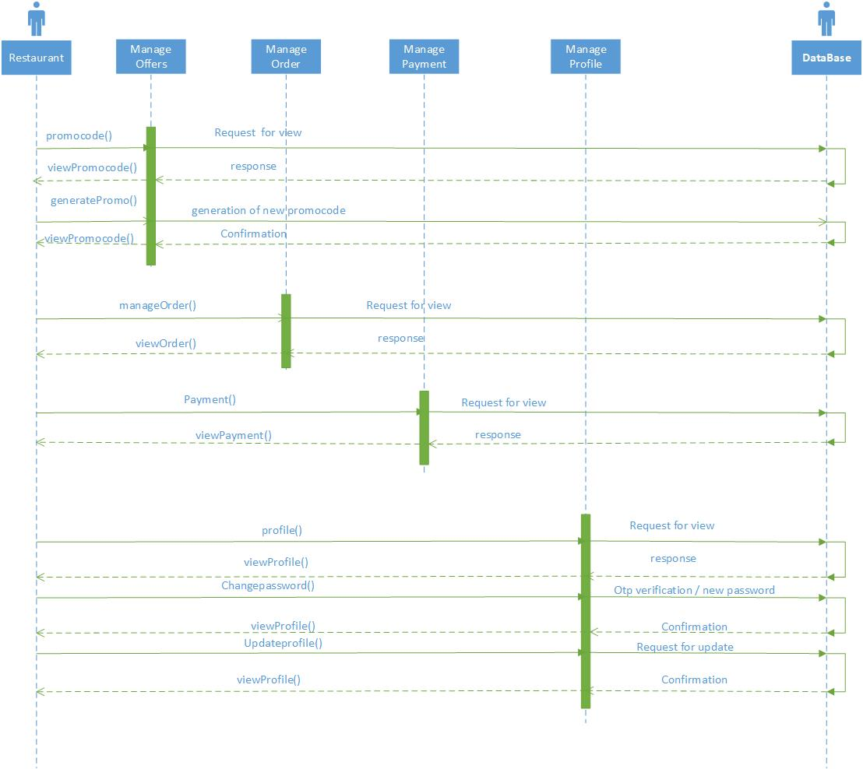

**3.3. Database Design: -**

**3.3.1. E-R Diagram: -**

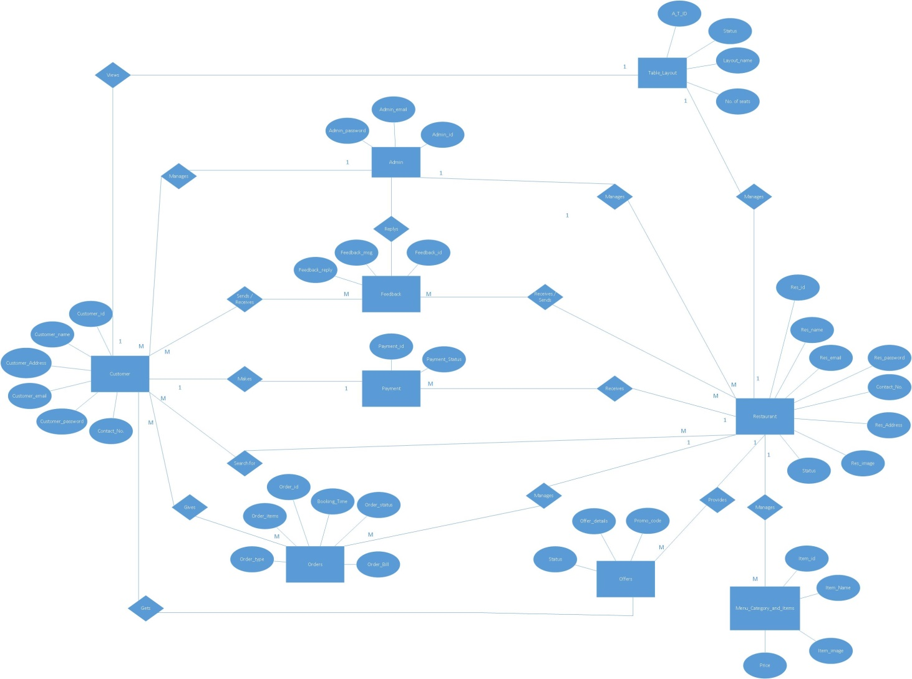

**3.3.2. Data Dictionary: -**

## 

## 

## 

## 

## 

## Chapter 4: System Description: -

## 4.1. Software Description: -

## 4.1.1. Android Studio: -

Android Studio contains tools such as the Android Virtual Device Manager and the Android Device Monitor. It also contains Gradle, which helps you configure your Android application seamlessly. Some of the interesting features of Android Studio include the following:

* Support for a fast emulator
* Support for Gradle
* Support for plenty of code templates and GitHub integration
* Support for Google Cloud Platform
* Support for template-based wizards for creating Android designs and components
* Support for rich layout editor
* Support for deep code analysis
* Support for extensive set of tools and frameworks

**4.1.2. MySQL: -**

MySQL is an open-source, fast reliable, and flexible relational database management system, typically used with PHP.

* MySQL is a database system used for developing web-based software applications.
* MySQL used for both small and large applications.
* MySQL is a relational database management system *(RDBMS).*
* MySQL is fast, reliable, and flexible and easy to use.
* MySQL supports standard SQL *(Structured Query Language).*
* MySQL is free to download and use.

**4.1.3. Sublime Text: -**

Sublime Text Editor is a full featured Text editor for editing local files or a code base. It includes various features for editing code base which helps developers to keep track of changes.

* Ability to solve linker errors.
* Keeping track of all files and folders to work with.
* Connectivity with version control systems like Git, Mercurial.
* Problem solving capabilities.
* Keeping colour combination for syntax combination.

**4.1.4. XAMPP Server: -**

* XAMPP is one of the widely used cross-platform web servers, which helps developers to create and test their programs on a local webserver.
* XAMPP is an abbreviation where **X stands for Cross-Platform, A stands for Apache, M stands for**[***MYSQL***](https://www.javatpoint.com/mysql-tutorial)**, and the Ps stand for PHP and Perl**, respectively. It is an open-source package of web solutions that includes Apache distribution for many servers and command-line executables along with modules such as Apache server, [MariaDB](https://www.javatpoint.com/mariadb-tutorial), PHP, and Perl.

**5. Chapter 5: System Implementation : -**

**5.1 TESTING PLANNING**

There are mainly three techniques used for software testing.

**1)White Box Testing**: White box testing is the detailed investigation of internal logic and structure of the code. White box testing is also called glass testing or open box testing. In order to perform white box testing on an application, the tester needs to possess knowledge of the internal working of the code. The tester needs to have a look inside the source code and find out which unit/chunk of the code is behaving inappropriately.

**2)Black Box Testing:** The technique of testing without having any knowledge of the interior workings of the application is Black Box testing. The tester is oblivious to the system architecture and does not have access to the source code. Typically, when performing a black box test, a tester will interact with the system's user interface by providing inputs and examining outputs without knowing how and where the inputs are worked upon.

**3)Grey Box Testing:** Grey Box testing is a technique to test the application with limited knowledge of the internal workings of an application. In software testing, the term the more you know the better carries a lot of weight when testing an application. Mastering the domain of a system always gives the tester an edge over someone with limited domain knowledge. Unlike black box testing, where the tester only tests the application's user interface, in grey box testing, the tester has access to design documents and the database. Having this knowledge, the tester is able to better prepare test data and test scenarios when making the test plan.

**TESTING STRATEGIES :**

A test strategy is an outline that describes the testing approach of the software development cycle. It is created to inform project managers, testers, and developers about some key issues of the testing process. This includes the testing objective, methods of testing new 33 functions, total time and resources required for the project, and the testing environment. Test strategies describe how the product risks of the stakeholders are mitigated at the testlevel, which types of test are to be performed, and which entry and exit criteria apply. They are created based on development design documents. System design documents are primarily used and occasionally, conceptual design documents may be referred to. Design documents describe the functionality of the software to be enabled in the upcoming release. For every stage of development design, a corresponding test strategy should be created to test the new feature sets.

**5.2 TEST LEVELS**

Levels of testing include the different methodologies that can be used while conducting Software Testing. Following are the main levels of Software Testing:

**• Functional Testing**

Unit Testing: This type of testing is performed by the developers before the setup is handed over to the testing team to formally execute the test cases. Unit testing is performed by the respective developers on the individual units of source code assigned areas. The developers use test data that is separate from the test data of the quality assurance team. The goal of unit testing is to isolate each part of the program and show that individual parts are correct in terms of requirements and functionality.

**Integration Testing:**

The testing of combined parts of an application to determine if they function correctly together is Integration testing. There are two methods of doing Integration Testing Bottomup Integration testing and Top-down Integration testing.

**5.3 SYSTEM TESTING:**

This is the next level in the testing and tests the system as a whole. Once all the components are integrated, the application as a whole is tested rigorously to see that it meets Quality Standards. This type of testing is performed by a specialized testing.

**Regression Testing:**

Whenever a change in a software application is made it is quite possible that other areas within the application have been affected by this change. To verify that a fixed bug hasn't resulted in another functionality or business rule violation is Regression testing. The intent of Regression testing is to ensure that a change, such as a bug fix did not result in another fault being uncovered in the application.

**Acceptance Testing:**

This is arguably the most importance type of testing as it is conducted by the Quality Assurance Team who will gauge whether the application meets the intended specifications and satisfies the client’s requirements. The QA team will have a set of pre written scenarios and Test Cases that will be used.

**Alpha Testing:**

This test is the first stage of testing and will be performed amongst the teams (developer and QA teams). Unit testing; integration testing and system testing when combined are known as alpha testing.

**Beta Testing:**

This test is performed after Alpha testing has been successfully performed. In beta testing a sample of the intended audience tests the application. Beta testing is also known as prerelease testing. Beta test versions of software are ideally distributed to a wide audience on the Web, partly to give the program a "realworld" test and partly to provide a preview of the next release.

* Below are the snapshots of our project for **customers** :-
* The first step is to register into our app and then do login after making an account.

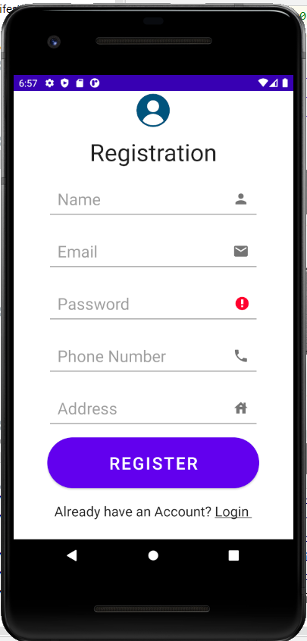 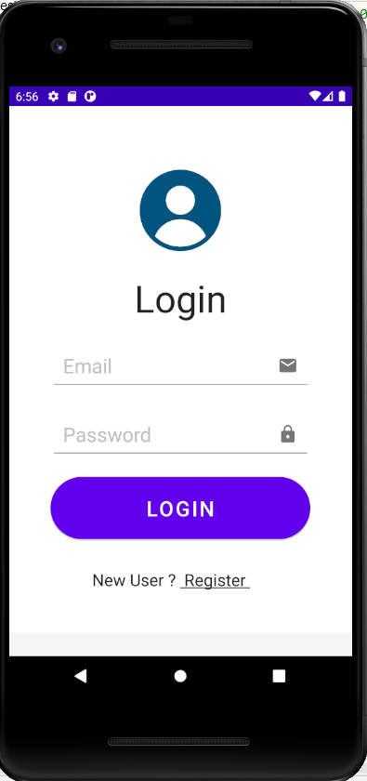

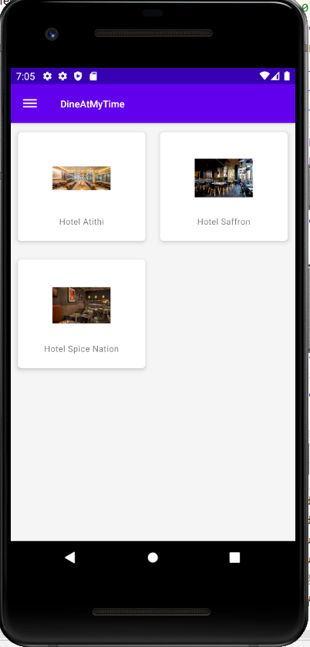 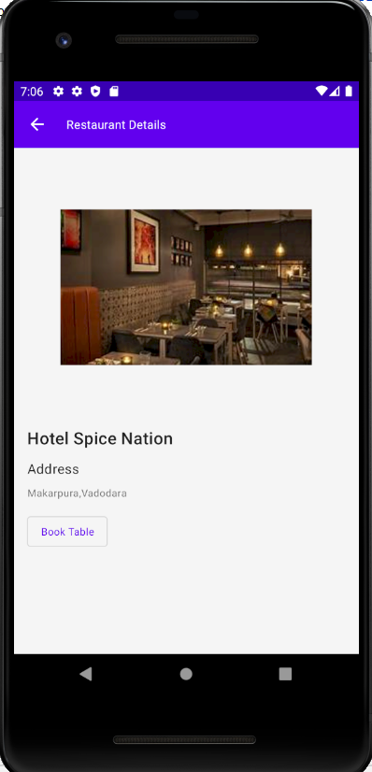

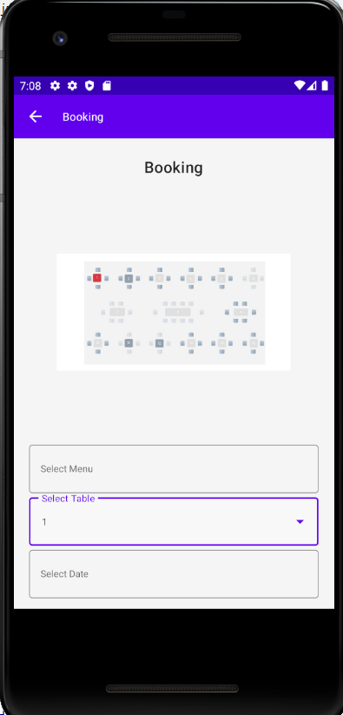 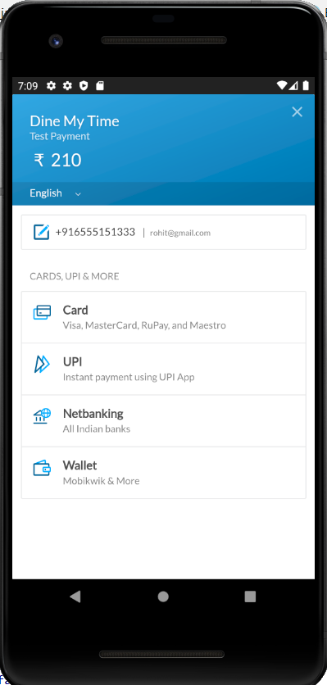

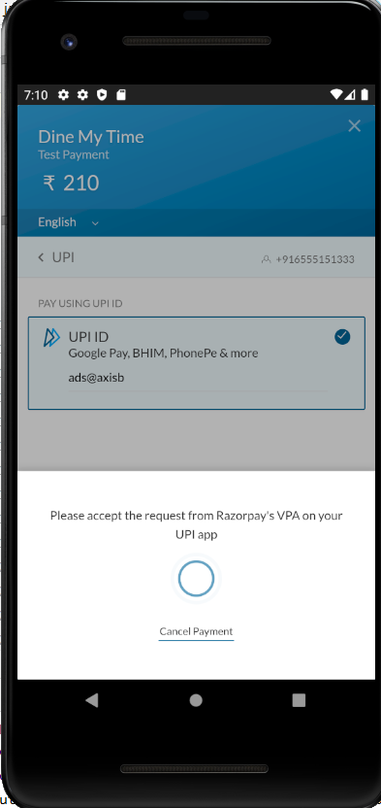 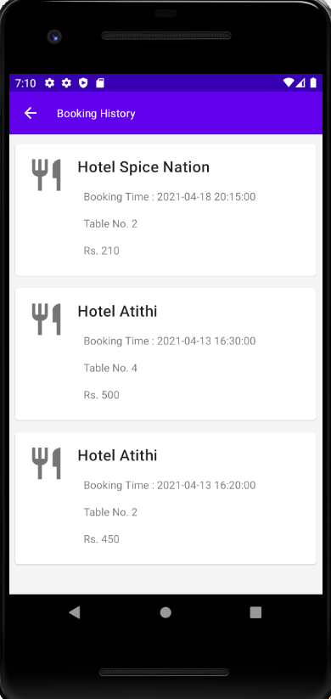

* Below are the snapshots for **restaurant side :**

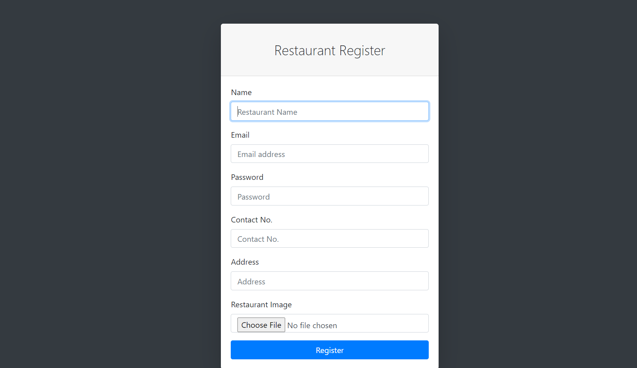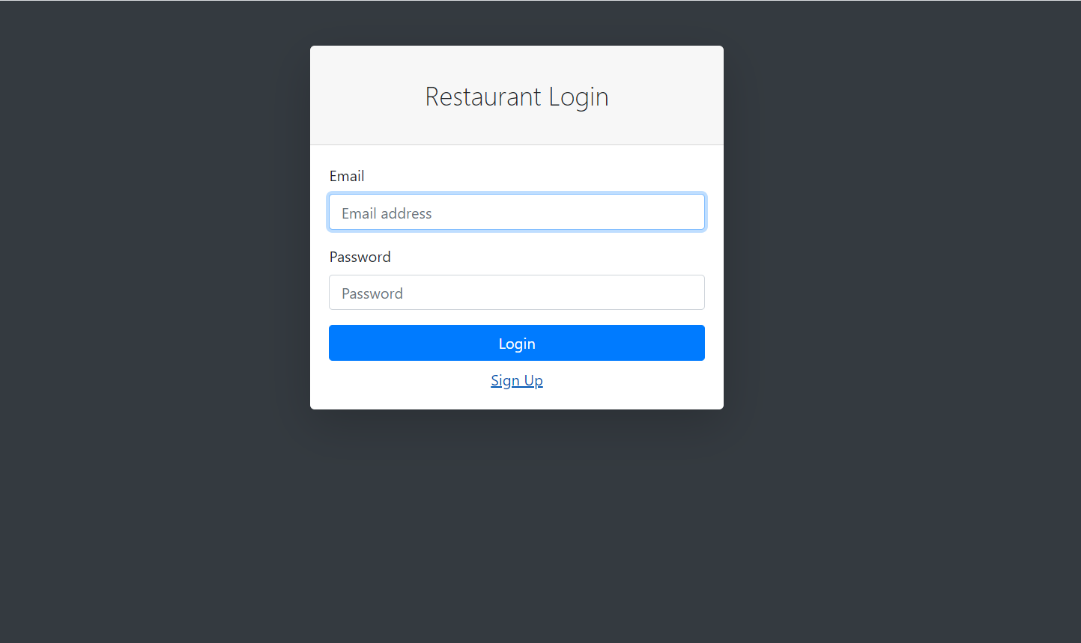

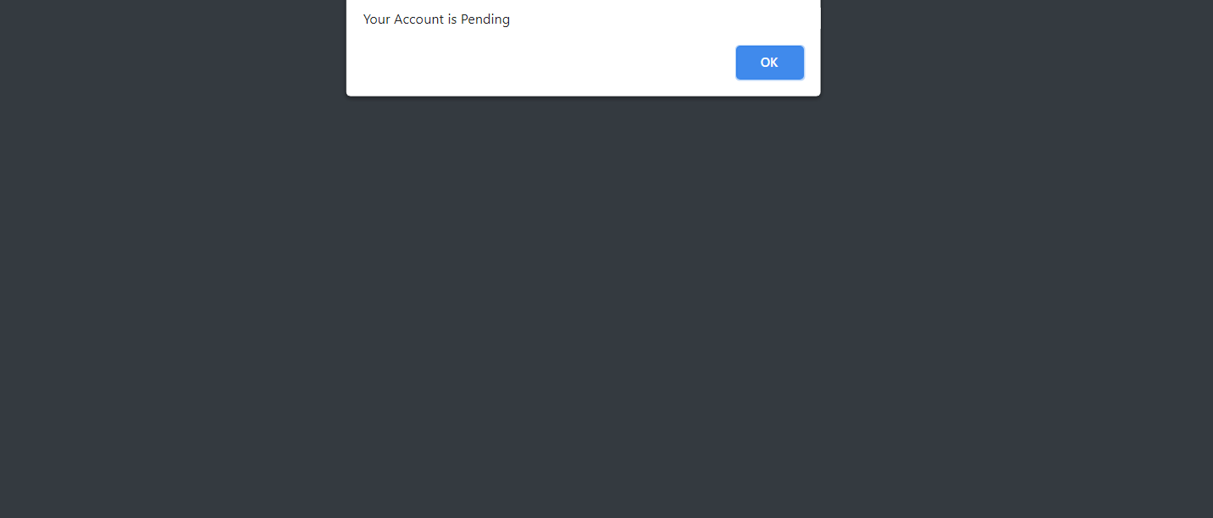

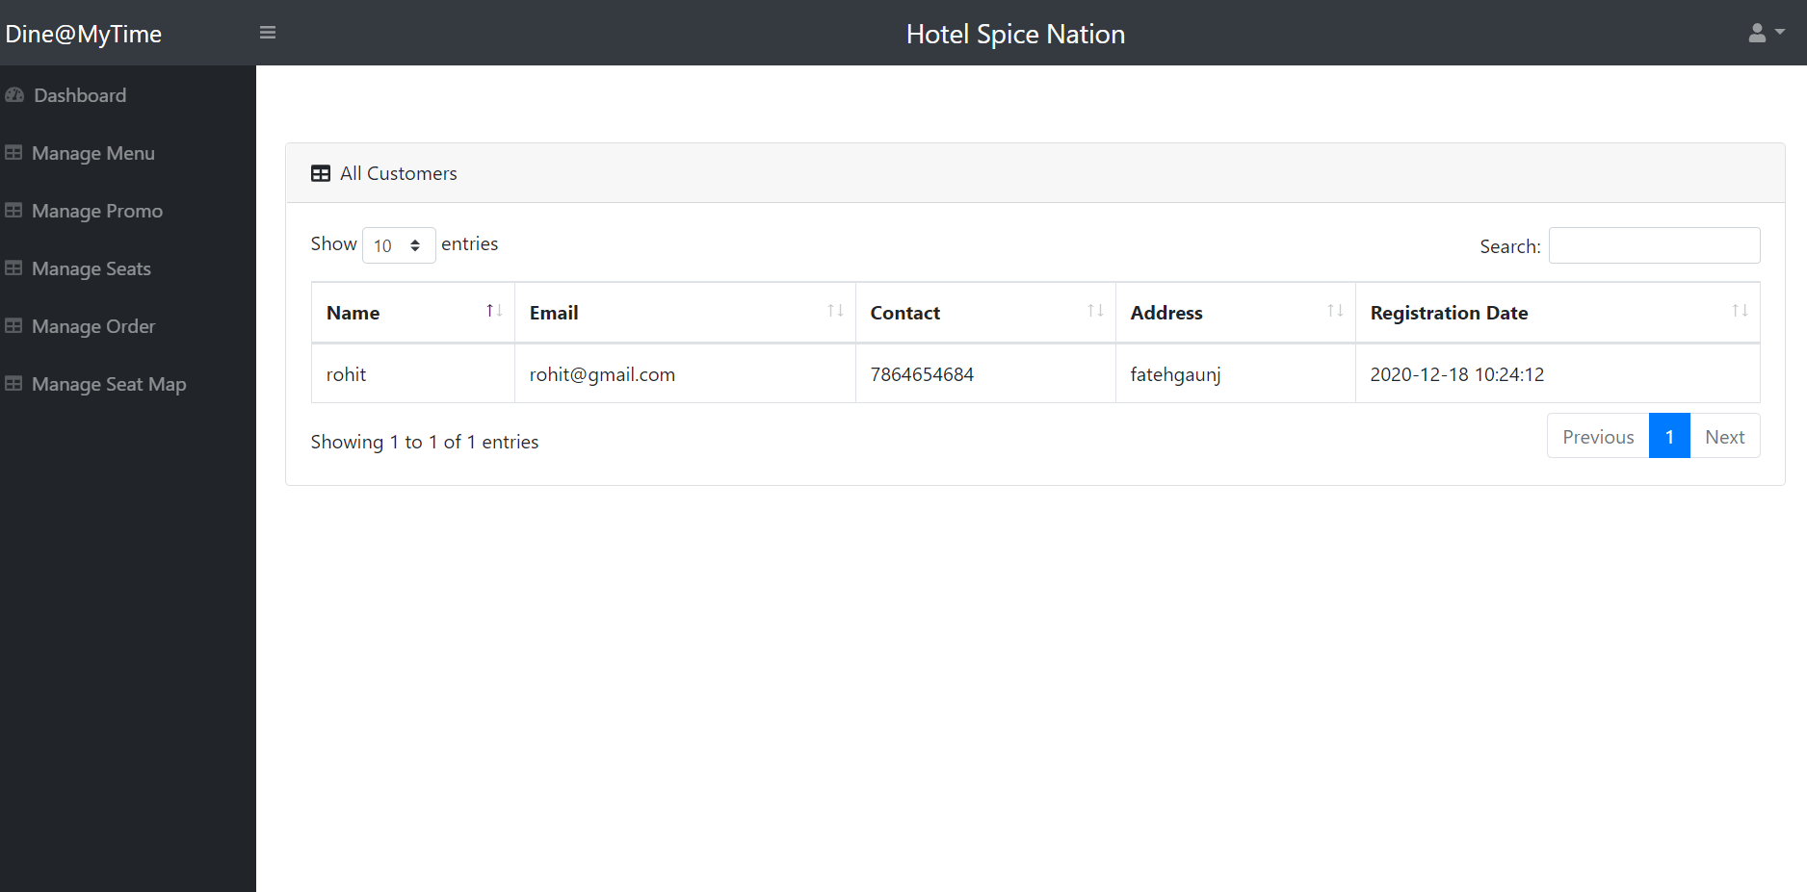

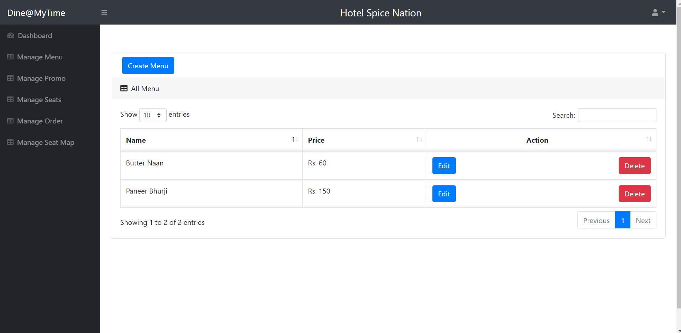

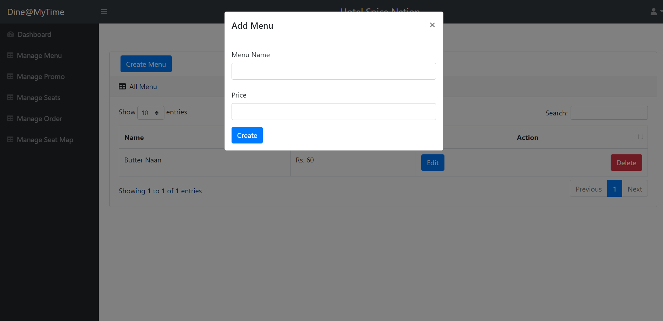

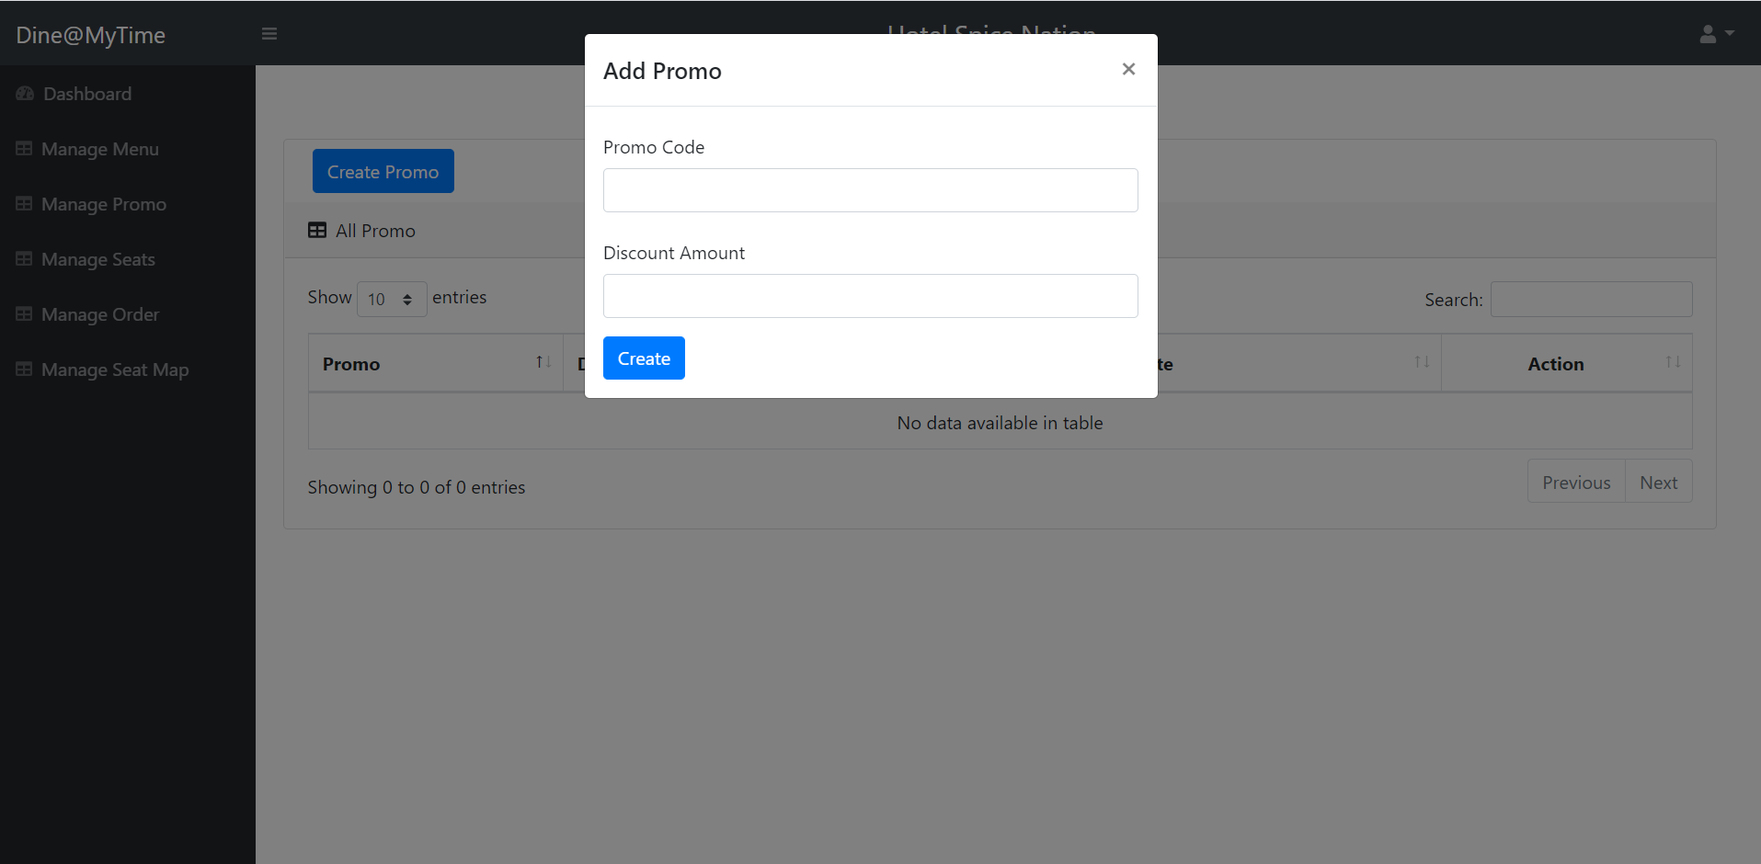

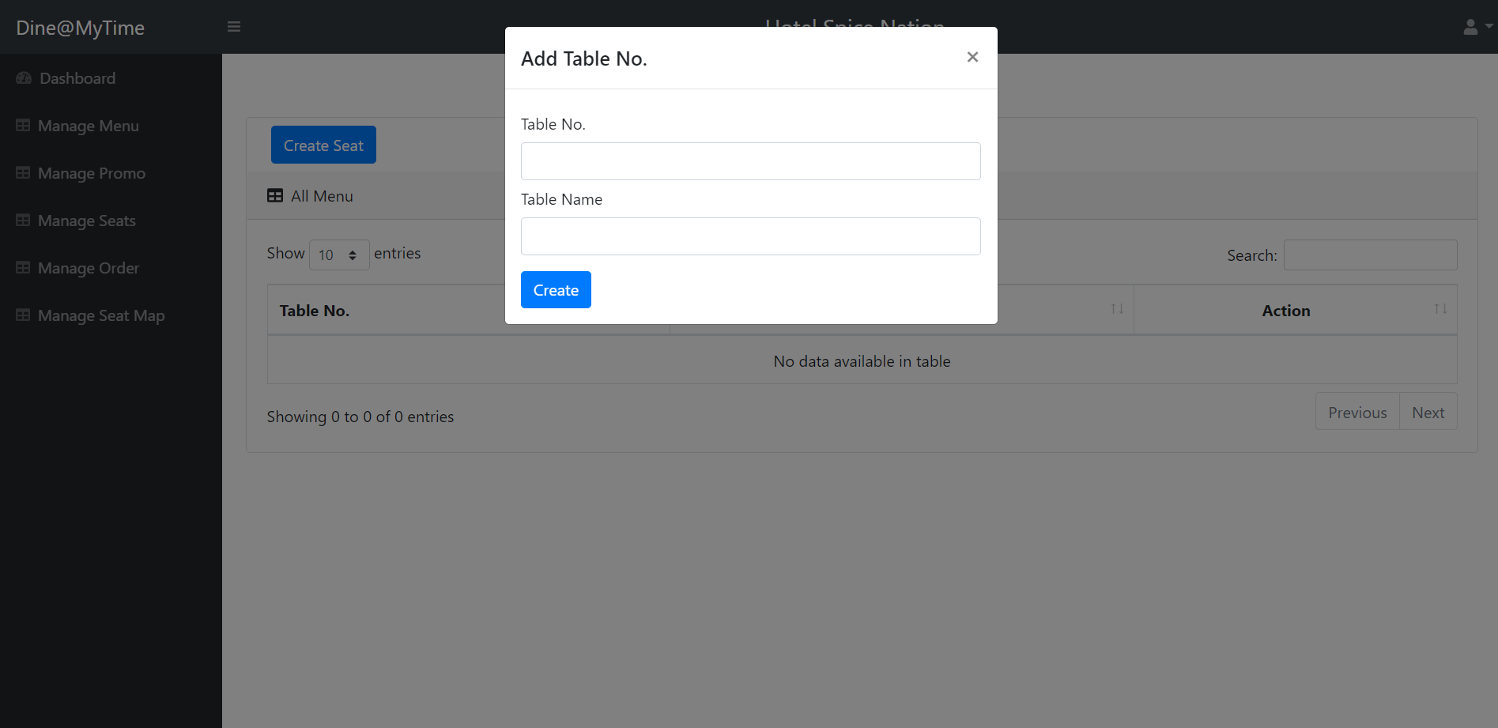

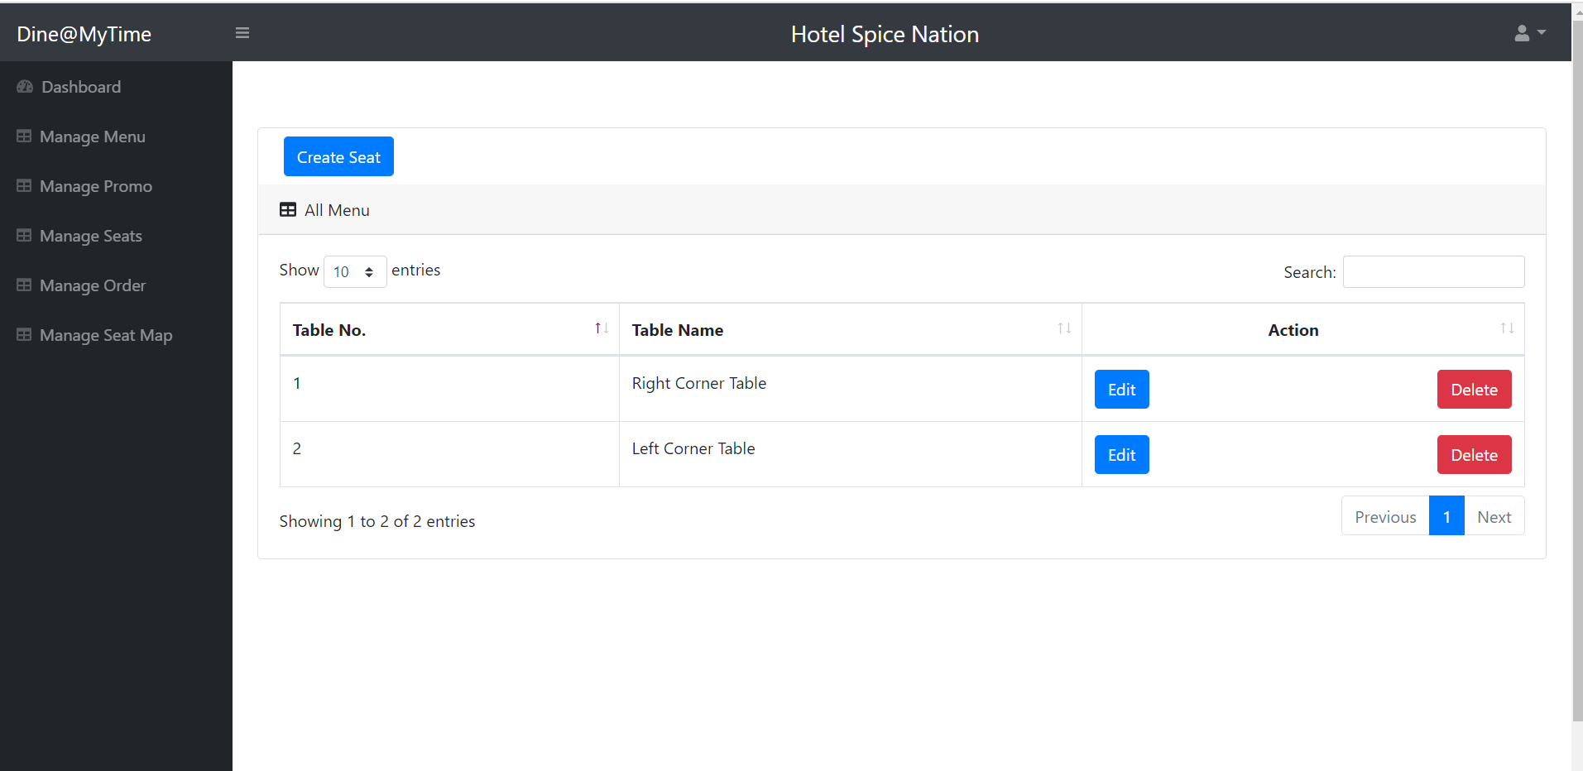

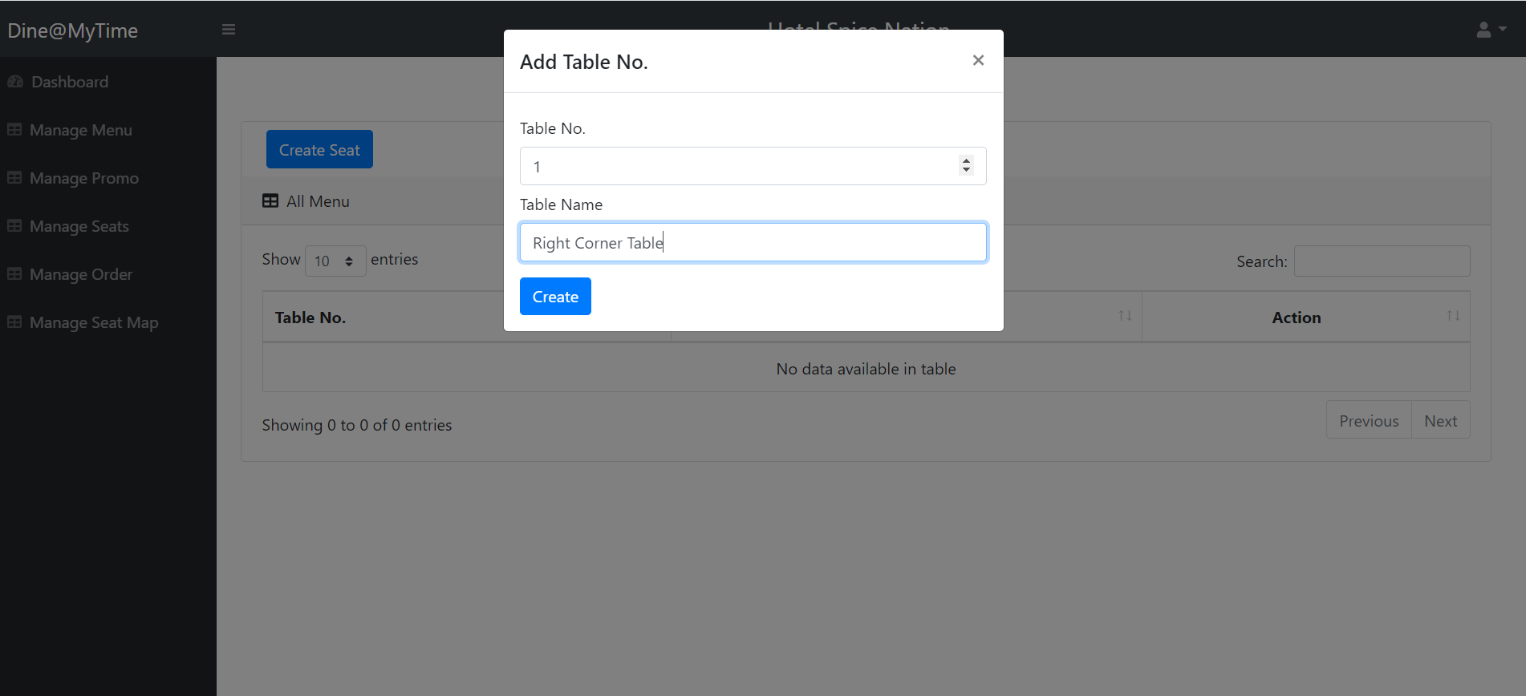

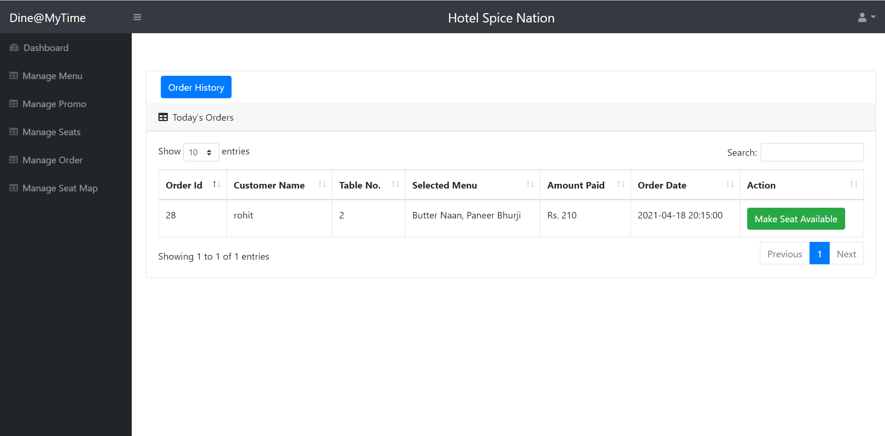

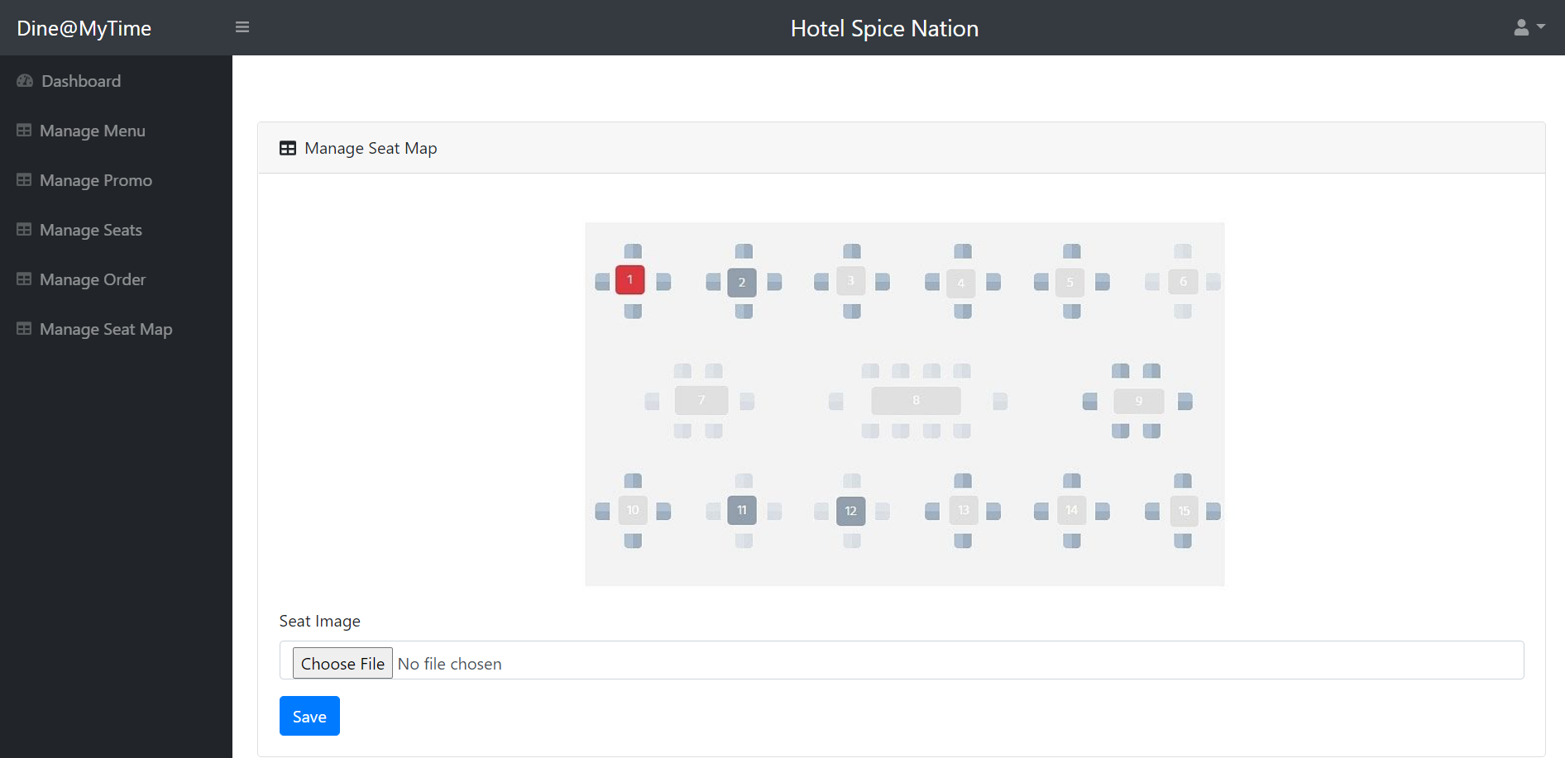

* Below are the snapshots for **Admin Panel** :

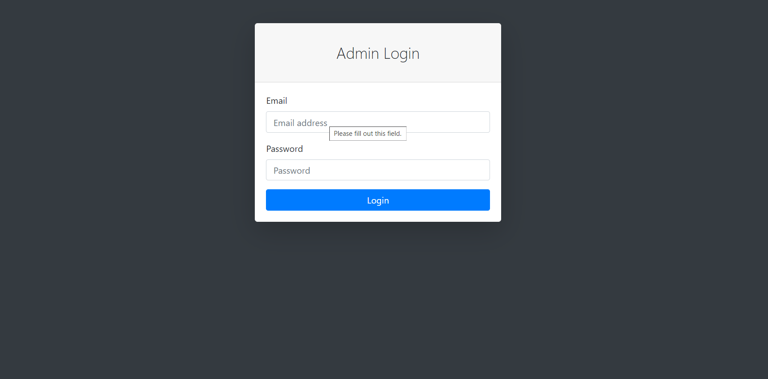

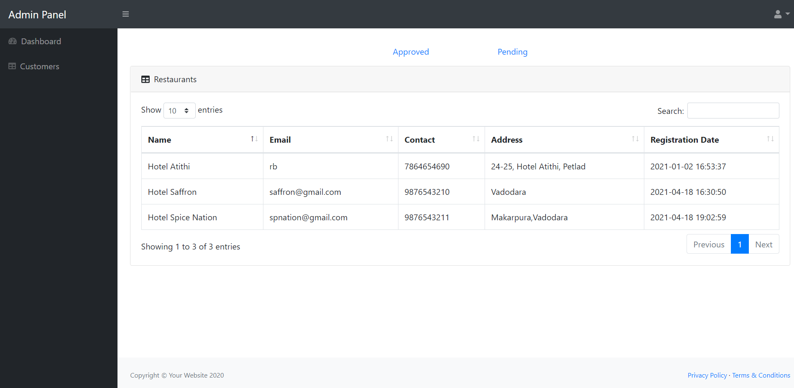

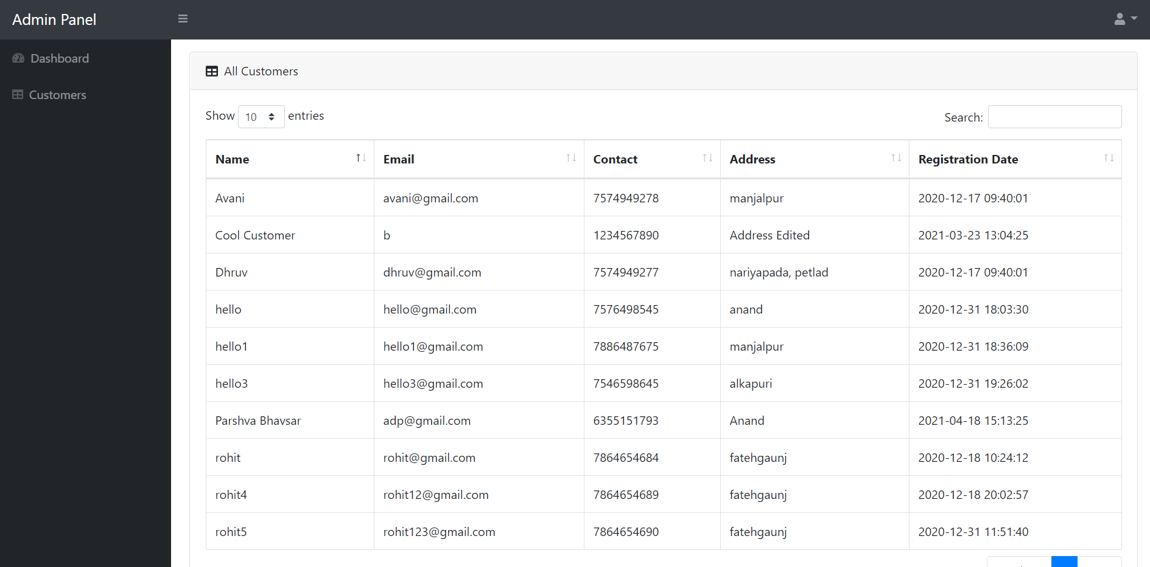

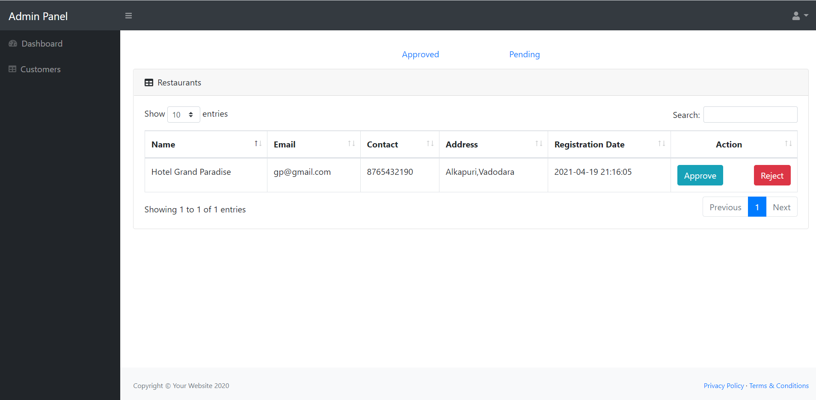

**6. Chapter 6: Conclusion and future scope: -**

**Reference: -**

* **Book References:**

1. Software Engineering – A Practitioner’s Approach Author: Roger S. Pressman

* **Web References: -**

1. Timeline chart/ Gantt Chart

<https://infograph.venngage.com/templates/infographics/timeline>

**Appendix A: Canvas:-**



 

 